 | February 2014 | Hillary Clinton ‘called Monica Lewinsky a loony toon’  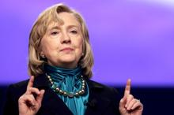  Hillary Clinton denounced Monica Lewinsky as a “narcissistic loony toon” after revelations of the intern’s affair with Bill Clinton, it emerged yesterday. The remark was made in a 1998 telephone call from the President’s wife to Diane Blair, a friend, and is recorded in a previously unexamined  February 11 2014 12:01 AM

President Hollande hopes to leave domestic woes back home on trip to US
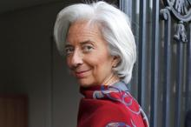
America and France will today try to project their repaired alliance as a model for international leadership as President Hollande tries to put the disasters in his personal life behind him. The French leader will be honoured by Barack and Michelle Obama at a state dinner in a heated pavilion on
February 11 2014 12:01 AM
 | February 2014 | China joins Obama as world condemns North Korea’s new ‘uranium’ bomb test  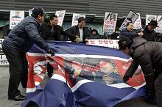  President Obama last night led global condemnation of North Korea after its detonation of what it described as a miniaturised nuclear bomb. The pariah state’s action, denounced as “highly provocative” by Mr Obama, also brought criticism from its ally China, followed by an emergency meeting of the  February 10 2014 7:28 PM

